Using the World Airline Network for Understanding the Spreading of a Pandemic

3rd May 2022

Abstract: This paper explores how an epidemic can spread through a global air travel network and become a global pandemic using an SIR model. Different network types were explored, SIR scenarios were tested (using different recovery and transmission rates) and random node and eigenvector node removal was undertaken. A lower infection rate (tau) compared to recovery rate results in an overall lower infection time of the network. To prevent a pandemic from spreading the removal of eigenvector central nodes could be an effective approach.

Keywords: Susceptible-Infected-Recovered, Networks Analysis, Pandemic Spreading, Eigenvector Centrality.

# **Introduction**

Between the December 31st and 3rd January 2019, 44 cases of pneumonia with an unknown cause were observed in Wuhan, China. On the 6th of January 2019 the sickness was identified as the novel Coronavirus 2019 (COVID-19). One month after its initial observation, over 100 cases were seen outside of China, reaching as far as Europe and the Americas resulting in 1.3m confirmed cases, and over 75,000 deaths [1]. The following 24 months saw rapid growth and infections across the globe. 225 Countries and Territories have seen cases resulting in over 6 million deaths worldwide [2]. Airports directly benefit governments, consumers, to businesses through a fast and effective collection of worldwide network connections [3]. Many restrictions were placed on international flying during the height of the pandemic as a method of preventing its spread. This in turn reduced the connectedness of the global air transportation network. Several studies in extant literature point to COVID-19 spreading via air travel [4]. However, many of these studies focus on specific regions rather than a global network of flights [*ibid*]. This paper explores how an epidemic can spread through a global air travel network and become a global pandemic using an SIR model (Susceptible-Infected-Recovered). It aims to (a) examine degree distribution and the distribution of eigenvector centrality across several types of network edge connections (undirected and unweighted network, directed and unweighted network and directed and weighted network). (b) Run an SIR model over the air travel network, testing different transmission rates and recovery rates and plotting results (c) perform time step simulation (100 times) across the network, providing analysis of the degree of each node, the distance of each node to the initially infected node, quantifying the average airports in each country and (d) perform node removal analysis. Following the analysis, the objective of this study is to highlight and discuss potential measures that could be taken to avoid future pandemics. To achieve this, this paper first provides literature review covering related work in the field of network analysis and epidemic/pandemic spreading via world network airlines. Second, an overview of the dataset used in this study will be detailed, including its structure and how it has been analysed. Third, an overview of the network analysis methodology undertaken, and assumptions made will be covered. Fourth, results from the network analysis will be presented and critically discussed. Lastly, this paper will provide a summary covering the analysis undertaken, its limitations and perspectives on how it could be extended for the benefit of further research in the domain of epidemic modelling using a global airline network.

# **Literature Review (related work**)

## **Complex Networks Analysis**

Complex networks are networks that represent real systems consisting of nodes connected by edges. An example could be a social media platform where nodes would be users and friend connections would be edges. The definition of a complex network can be extended with the inclusion of, *inter alia* directed edges (a one-way relationship between connected nodes), undirected (a two-way relationship between connected nodes), time-dependence or population flux weights [5] Complex networks can be seen in human relationships and biological networks. A common feature is the so-called small world property, meaning the network has a small mean path length (i.e., the number of hops from one node to another) [6] [7]. A small mean path length results in high connectivity between nodes. This, for example, can mean information and diseases can be effectively passed throughout a network. Another common feature of a small world network is a high clustering coefficient [7] which is the probability that two randomly selected nodes connected to a node are connected to each other [8]. As part of a 2003 airport network analysis of 3883 cities (nodes), and 27,051 pairs (edges), it was found that a global airport network (a) indicated small world, and (b) scale-free network properties [9]. A scale-free network exhibits a heterogenous degree distribution, where few important nodes (hubs) have many connections to other nodes in the network, and most nodes have very few connections. This results in a long tail degree distribution of nodes in the network [10]. Another key facet of complex networks is eigenvector centrality which considers the centrality of nodes that a node is connected to, thus measuring the influence a node has in the network [11].

## **Modelling Epidemics**

Modelling epidemics can be captured under three domains: (1) Agent Based (such as random walk); (2) Complex Network Models (such as numerical simulations of complex small world and scale-free networks); and (3) Mathematical Models (such as compartmental models). Each of the three domains range from simple low computing requirements (Low Computing Models) to detailed complex high computing power (Agent Based) [12]. Endowed by their implementation simplicity, *Mathematical Models* can enable macroscopical study of epidemic diffusion using compartmental models [ibid]. The Susceptible-Infected Recovered (SIR) is an example of a compartmental model that calculates the number of individuals at any point in time that are (a) suspectable to infection, (b) are infected, or (c) have recovered from infection. The SIR model assumes an *infected* person will infect a *susceptible* person they encounter. This in turn renders the susceptible person infected for a fixed period, after which they *recover* (or die) and as such lose their ability to infect [13]. It has been argued that the SIR model can overgeneralise in the assumptions it makes. For example, as part of research conducted by Newman [14] it was stated that patterns in the real world represent a well-defined social network, but some SIR models assume a ‘fully mixed’ approximation whereby every individual has an equal chance of contacting each other. Research undertaken by Goel *et al*. [15] adds to this critique in their analysis of a fully mixed SIR model and proposed novel model titled a *‘mobility-based SIR model for complex networks’*. In their study they argued that an individual interacts with a limited quantity of other people and forms a complex network. This so-called complex network does not share topological features akin to what is seen in lattices or random graphs. I.e., complex networks exhibit a heterogenous topology.

The focus of this research is within the domain of complex network models. Complex network models can include the numerical analysis of networks using compartmental models. For example, 2001 research [16] of computer virus infections studied a compartmental model using large scale-free numerical network simulations. As part of the study, the researchers found scale-free networks are prone to spreading and persistence of infection whatever spreading rate the epidemic agent poses. It should be noted that the compartmental model used in this study was susceptible-infected-susceptible (SIS) model. Unlike the SIR model the SIS only considers suspectable and infected people, which means the process of infection can potentially run indefinitely [17]. Later research [18] undertook computer simulations of generated networks using: (a) Watts-Stogatz (WS) model, which is a prototype network exhibiting small-world properties [8]; and (b) Barabasi and Albert (BA) model, which is a prototype [scale-free](https://en.wikipedia.org/wiki/Scale-free_network) network [19]. The authors tested a SIS model alongside increasing immunisation rates. The findings, *inter alia,* included: (a) For WS the fraction of immunised nodes in both random targeted immunisation and uniform immunisation produced the same results in terms of the decay of the prevalence of infected nodes, meaning there was no efficiency to be gained from a targeted immunisation strategy. The authors argued that this supports the notion of global vaccinations in order to reach a density of immune people in a homogonous networks (b). Contrary findings were seen in the BA model, whereby the decay of the infected nodes decayed slowly as the fraction of immunised nodes increased. The authors stated that this points to the weakness of scale-free networks when faced with epidemics, even after large scale uniform immunisation schemes. The study also demonstrated that targeted immunisation strategies produce a faster decay in infected nodes when compared to uniform immunisation strategies. This finding aligns with the concept that a scale-free network has a small number of important nodes that have many connections to other nodes in the network [10]. Analogous findings were also captured in research conducted by Moreno *et al.* [20] that studied epidemic outbreaks in complex heterogenous networks using prototype WS and BA networks. The authors argued that network topology is a key factor in the influence of how a virus can spread. In addition, the research found there was no epidemic threshold for the scale-free networks studied, which is the point at which an epidemic would start spreading. This was also corroborated in later studies that demonstrated that scale-free networks will perpetually propagate regardless of the spreading rate. In this research the authors studied two networks namely, (a) random scale-free network; and (b) small world network with scale-free network properties [21].

## **Air Transportation Disease Spread Modelling**

Air transportation can act as a vector for epidemic /pandemic spreading. Air transportation networks are believed to include heterogenous connections and few cities can capture large amounts of network traffic, enabling the global spread of disease [22]. This was also described by Colizza *et al*. [23] in their research including 3,100 airports and 17,182 edges accounting for 99% of worldwide air network traffic. The International Air Transport Association database containing a world list of airports and the number of available seats was used alongside corresponding urban population data. An SIR model was also employed as a tool to study the spread of an epidemic in the airline network. The network edges were weighted to account for passenger movement between airports. The probability distribution of the airline network exhibited a heavy tail, meaning the degree distribution followed the power law. The research compared the world airline network (WAN) with two network prototypes, namely an homogonous random graph (HOMN) and a network (HETN) that retained the same heterogonous topology as the WAN. However, for both HOMN and HETN passenger movement and populations were uniform based on the average of the WAN network. The findings indicated over 90% of nodes were infected for a longer time in HOMN when compared with WAN and HETN, which produced similar results. Noting that HOMN and HETN had a uniform weighting, it was argued that the broad nature of the degree distribution in a network determines the spreading pattern of an epidemic. The findings presented in the study are particularly interesting considering that not all flights are equal in terms of airline capacity and traffic flow of people.

# **Dataset and network presentation**

#### **Data Overview**

Extant literature points to the importance of airports at influencing the spread of an epidemic across a world-wide network [24]. In this study the authors have used datasets that derive from Open Flights database that represents global flight paths as at 2017 [25]. The data contains: airport ID, name of airport, city, country 3 letter IATA code, 4 letter ICAO codes, flight path longitudinal and latitudinal coordinates, and time zones. From the Open Flights database, Routes data have been used for nodes and edges. Airports-extended data for longitude and latitude coordinates. The authors have summarised various statistics in Table 1 below. It should be noted that the summary statistics provided below are in relation to an unweighted and undirected graph. Additional analysis, graph direction and weights have been applied as part of this study. A total of 3,425 nodes, and 37,595 edges were observed. The total nodes (airports) in the network broadly align with previous studies of world network airlines [22][23]. However, the quantity of edges identified in the network are larger than other studies [23][24]. The network diameter is 14, which the greatest distance (hops) between any two nodes in the network [7]. The average clustering coefficient is 0.467 indicating that the network exhibits small world characteristics [*7*]. This observation is harmonious with findings from Diop *et al.* [26], which means that there is a high connectivity clustering of airports (nodes). The highest degree node totals 477 ties with other nodes (Frankfurt Airport). This node therefore has a high influence in the network regarding the spread of information/disease.

| **Dataset Description** | | **Statistics** |
| --- | --- | --- |
| Nodes (airports) | 3,425 | |
| Edges (flights paths) * | *37,595* | |
| Network Diameter (*D*) | 14 | |
| Average Path Length (*L*) | 4.146​ | |
| Highest Degree Node (*k*) | 477​ | |
| Average Clustering Coefficient | 0.467​ | |

Table 1- Open Flights Data Summary Statistics

*\*Total edges including parallel edges: 67,663. The edges stated above (37,595) merge all parallel edges.*

##### **Network analysis methodology**

The network analysis is composed of four key tasks. The below provides an overview of the methodology adopted for each of the tasks.

**Task 1 - Analysis of the Centrality:**This task provides analysis of different network structures and draws from different researchers in the field of airport network analysis. For example, previous research included a world-wide airport weighted network and *inter alia* provided analysis of eigenvector centrality [27]. Later research conducted by Diop *et al* [26] used an unweighted and undirected airport network data to provide*, inter alia,* analysis of centrality measures such as degree distribution. They recommended that using the appropriate tools one could extend analysis to weighted and directed networks. The authors in this study have extended the above to include different network types, covering both degree distribution and eigenvector centrality. The routes.dat dataset from openflights.org [25] was used to obtain connected nodes only. Each dataset on python was cleaned from unnecessary columns, leaving only ‘Source airport’ and ‘Destination airport’ for each edge. The dataset was then loaded into a pandas’ data frame, and NetworkX library was then used to create three graphs (a) Undirected and unweighted network.; (b) Directed and unweighted network (c) Directed and weighted network. To perform an analysis on the three different cases, the authors plotted the degree distribution of each network by calculating the degree of each node and plotted the eigenvector centrality distribution of each after computing it using NetworkX. This enabled the authors to examine degree distribution and the distribution of eigenvector centrality across the different types of network edge connections.

**Task 2 - SIR Modelling (different recovery and transmission rates):** The focus of this task is within the domain of complex network models and includes analysis using a compartmental SIR model on the undirected and unweighted network obtained from Task 1 above. For this task [EoN](https://epidemicsonnetworks.readthedocs.io/en/latest/functions/EoN.fast_SIR.html) [28] was used and the initial infected node was set to WUH (Wuhan). The approach adopted shares similarities with research conducted by Shu *et al,* [29] which, *inter alia*, included numerical analysis of four real world complex networks to show how recovery rate affects spreading dynamics using an SIR model. They applied different rates for recovery, (i.e., 0.2,0.6 and 1) and transmission (0.23. 0.60). The authors in this paper have also adopted a similar approach to ref [29] using synchronous updating of all nodes simultaneously in the network. Further, three scenarios were run in this analysis with varying tau (transmission rate per edge), and gamma (recovering rate per node) values to observe the trends in number of Susceptible, Infected and Recovered nodes. Unlike the research in ref [29] we have applied the SIR model to a global airport network and the tau and gamma values applied are: (a) Scenario 1: tau= 0.3 and gamma= 1. (b) Scenario 2: tau = 1 and gamma =1 (c) Scenario 3: tau = 1 and gamma = 0.3.

Task 3 - SIR Modelling (run 100 times with fixed recovery and transmission rates): This task expands on Task 3 above, using the same undirected and unweighted network obtained from Task 1. Like Task 2, the initial infected node was set to WUH (Wuhan). Unlike Task 2, tau and gamma were fixed at tau=1, gamma=0 and the simulation were repeated 100 times. The number of time steps it took to get infected was averaged over the 100 simulations.

Task 4 - Node Removal: This task includes two limbs. The first being random node removal and the second being most eigenvector central node removal. Node removal of complex networks is a well-researched field [30]. The first part of this task aims to add to this research. The number of time steps it took to get infected (averaging over the 100 simulations) was obtained from Task 3. The first section of this task including the use of NetworkX library to pop random nodes from the network, preserving Wuhan as the initial infection node. The removal was done starting at 5% up to 30% with a 5% increment at every step. The second part of this task included the targeted removal of nodes based on eigenvector central nodes starting at 5% up to 30% with a 5% increment at every step. The approach of this task complements previous research of the airport network of India that analysed the impact of high node centrality removal, such as airports that had a high degree [31]. As part of Task 4, the authors have included eigenvector centrality as a measure of centrality, which was not considered in the research conducted by ref 31.

##### **Results and discussion**

**Task 1 - Analysis of the Centrality:** The below covers the analysis of the degree distribution and the distribution of eigenvector centrality across different types of network edge connections:

1. Undirected and unweighted network (see Fig.1 and 2 first image from the left)
2. Directed and unweighted network (see Fig.1 and 2 second image from the left)
3. Directed and weighted network (see Fig.1 and 2 third image from the left)

Figure 1 - Network Degree Distribution

Figure 2 - Eigenvector Centrality

As shown in Figure 1, most nodes have a degree of less than 25. Therefore, these graphs represent scale-free networks, where most nodes have very low degree, but a few nodes (hubs) have a very large degree [10]. The highest degree node for the undirected, unweighted graph is the airport AMS (Amsterdam) (degree 248), while the highest degree node for directed, unweighted, and weighted graphs is the airport FRA (Frankfurt Airport) (degree 477). Each node in the directed network includes both the in-degree and out-degree of each node, while in the undirected network the degree is only counted once between two nodes, causing the highest degree to be almost half than in the directed networks. Although the computed eigenvector centrality values (see Figure 2) are different for every analysed graph, the most eigenvector central node is AMS in each network, hence AMS is the most influential node, followed by FRA which is just slightly lower even though it has highest degree in directed graphs.

**Task 2 - SIR Modelling (different recovery and transmission rates):**  As part of Task 2, the authors undertook analysis on the undirected and unweighted graph obtained from Task 1. Varying tau and gamma values were applied to observe the trends in number of Susceptible, Infected and Recovered nodes. The below provides an overview of the different scenarios that were run.

**SIR Model 1:** In the first case (Figure *3*) tau= 0.3 and gamma= 1, i.e., higher recovery than infection. It can be observed that it takes around 8 days for all nodes to get infected. It can also be observed that susceptibility rate rapidly drops over 2 days and drops constantly over a period of the remaining time. Since recovery rate is higher than infection rate, most nodes are recovered around day 4.

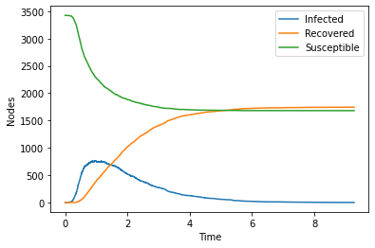

Figure 3 - SIR Model (tau= 0.3 and gamma= 1)

**SIR Model 2:** For the second plot (see Figure 4) tau and gamma were kept equal (1). It takes around 4 days for infection to spread, and susceptibility falls rapidly over 2 days and recovery rate increases rapidly over 4 days.

Figure 4 - SIR Model (tau= 1 and gamma= 1)

**SIR Model 3:** For the third scenario (see Figure 5) tau = 1 and gamma = 0.3, i.e., higher infection than recovery. With high infection rates, the number of infected nodes peaks on initial day and then subsides over the next 15 days. As expected, susceptibility falls sharply when infection is high and recovery rate rises later.

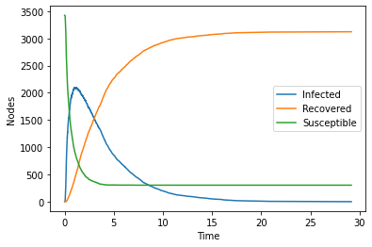

Figure 5 - SIR Model (tau= 1 and gamma = 0.3)

**Analysis of SIR Models** : From the 3 different scenarios it can be inferred that the rate at which susceptible nodes become infected is dependent on the number of nodes in each of the susceptible and infected compartments. Further, a lower infection rate (tau), when compared to the recovery rate, saw an overall lower infection time of the network (see Scenario 1 above). At the start of an outbreak, when there are few infected nodes, the disease spreads slowly. As more nodes become infected, they contribute to the spread and increase the rate of infection. Research undertaken by Tolles [32] found similar results and concluded that the result is a range of future trajectories, but this strategy does not formally quantify the uncertainty in the predictions, however their models had population as nodes instead of airports. The SIR model also makes several simplifying assumptions about the nodes. It assumes homogeneous mixing of the nodes, meaning that all individual nodes are assumed to have an equal probability of encountering the infection. [14].

**Task 3** *-* **SIR Modelling (run 100 times with fixed recovery and transmission rates)***:* As shown in Figure 6, several nodes with lower degree incur an early time of infection. This could be because those nodes are close to the initially infected node. It can also be seen that there is not much time difference between the nodes with degree near 50 and the nodes with degree near 250. This means that nodes with degree 50 are very well connected, and it is enough to rapidly spread the infection. A sample of the output of the simulation analysis can be seen in Figure 7. As shown, there are several nodes with a low degree and a low average infection time (*see infection avg column).* This could be due to these nodes being close to the initially infected node. A logarithmic plot also shows the distribution of degree vs time in Figure 8. As shown, nodes with degree 1 (log (1) = 0) is distributed from time 0 to 6. After degree of 32 (log (31.62) = 1.5) , all nodes are infected instantly, because they are very well connected in the network.

Figure 6 – SIR Model Infection Average Plot (Timesteps)

Figure 7 – SIR Model Infection Average Sample Output (Timesteps)

Figure 8 – SIR Model Infection Average Log Plot (Timesteps)

As shown in Figure 9, less connected countries like Greenland and Congo have greater infection time (i.e. the lighter the shade indicates the longer the time required to infect), while countries like India have a lower infection time (i.e. the darker the shade indicates the lesser time required to infect). China itself has extremely low infection time because it has the initially infected node (Wuhan), and it is well connected within the country. Also, many Europe countries and Northern Africa, which are highly connected, have low infection time.

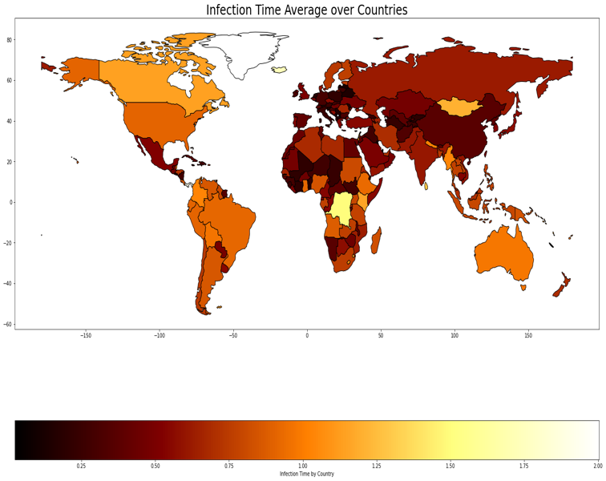

Figure 9 – Infection Time by Country

The map generated by the analysis and SIR simulation is remarkably similar from a visual perspective to the map generated by Nation Online [33] that uses real Covid data and illustrates outbreak cases by number. For example, in this papers analysis it was found that well-connected countries such as India and China were more susceptible to faster infection times. These countries have also shown to have some of the larger numbers of confirmed covid cases worldwide [ibid].

**Task 4 - Node Removal:**

**Incremental Node Removal:** As shown in Figure 10, a random node removal was done starting at 5% moving up to 30% with a 5% increment at every node removal step. After every removal step, a degree vs time graph was plotted to observe the effect of randomly removed nodes in the network.

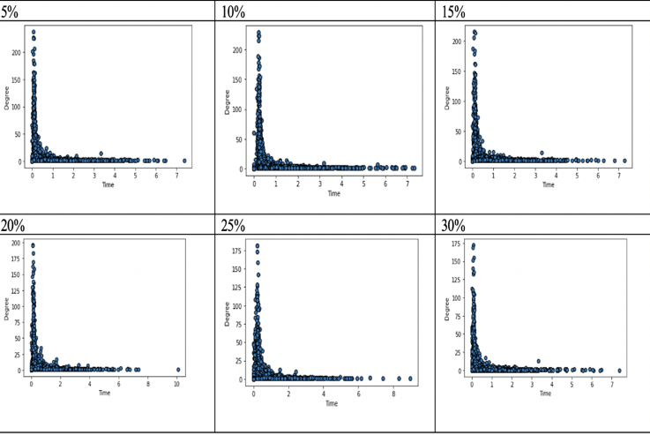

**Figure 10 - Incremental Random Node Removal**

As shown above the degree of the network degree keeps going down with every subsequent removal. It is above 200 at the first removal (5% removal) and approximately 175 at 30% removal. However, at 20% removal an anomaly was observed at time step 10, i.e., a highly central node was randomly removed causing one of the nodes to get infected in more time than it would normally take for it to get infected. The results align with research conducted by in ref [30]. Namely, their findings indicate that the robustness of a network is quite dependent on the degree of node/link failures.

**Node removal based on the most eigenvector centrality:** The below plots demonstrate (see Figure 11) the findings from node removal of the most eigenvector central nodes. Same as above the removal was done starting at 5% moving up to 30% with a 5% increment at every node removal step.

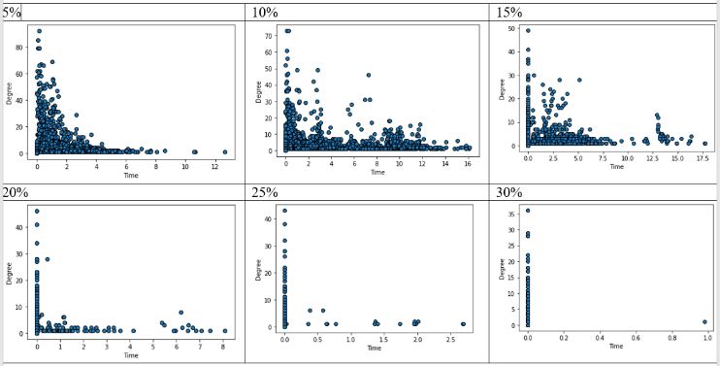

**Figure 11 - Incremental Node Removal based on the most eigenvector centrality**

As shown in Figure 11, the network keeps going down with every subsequent removal. It is above 80 at the first removal and approximately 35 at 30% removal. Also, the more eigenvector central nodes are removed, the longer it takes for all the nodes to get infected. The results align with research conducted by the authors of ref [30], which shows how the connectivity of scale-free networks is robust against random node removal, while on contrary the diameter of the network rapidly increases after removing hub nodes. Comparing this case with the random node removal, this case would be a more convenient measure to take to avoid a future pandemic. From the plots in shown in Figure 11, a network failure after 20% of top eigenvector central nodes are removed can be observed, which in case of a pandemic is what is needed to prevent infection from spreading. As such, the authors argue that to prevent a pandemic from spreading the removal of eigenvector central nodes could be an effective approach. This approach for example could include the isolation of highly connected airports

##### **Conclusions and Perspectives**

This paper explored how an epidemic can spread through a global air travel network and become a global pandemic using an SIR model (Susceptible-Infected-Recovered). Different network structures were explored (namely Undirected and Unweighted Network, Directed and Unweighted Network and Directed and Weighted Network) using the data set obtained from the Open Flights database. The authors found degree distribution similarities with all structures insofar as most nodes having a very low degree, but a few nodes (hubs) having a very large degree in each network structure. This is a key characteristic of a scale free network. An SIR model was run over the network, testing different transmission rates and recovery rates. From the 3 different scenarios it can be inferred that the rate at which susceptible nodes become infected is dependent on the number of nodes in each of the susceptible and infected compartments. Further, a lower infection rate (tau), when compared to the recovery rate, saw an overall lower infection time of the network (see Scenario 1 above). An SIR model was also run 100 times with fixed recovery and transmission rates. A world map of infection times was plotted and found to visually align to real world data. For example, in this papers analysis it was found that well-connected countries such as India and China were more susceptible to faster infection times and countries have been shown to have some of the larger numbers of confirmed covid cases worldwide. Random removal of nodes from the network saw a general reduction of the degree of the network with each iteration. A second node removal exercise was done on eigenvector central nodes only. It was found that the more eigenvector central nodes removed, the longer it took for all the nodes to get infected. As such, the authors argue that to prevent a pandemic from spreading the removal of eigenvector central nodes could be an effective approach. This approach for example could include the isolation of highly connected airports. That said, there still exists gaps between actual data, theoretical predictions, and model simulation for all networks inside each country, such as airport traffic and population. In addition, different compartmental models could be explored to account for heterogenous topologies.

# **REFERENCES**

1. Clarke, S., Voce, A., Gutiérrez, P. and Hulley-Jones, How coronavirus spread across the globe - visualised. [online] the Guardian. , (2022), Available at: <https://www.theguardian.com/world/ng-interactive/2020/apr/09/how-coronavirus-spread-across-the-globe-visualised> [Accessed 29 March 2022]
2. Worldometers.info. Countries where Coronavirus has spread – Worldometer, 2022.  [online] Available at: <https://www.worldometers.info/coronavirus/countries-where-coronavirus-has-spread/> [Accessed 29 March 2022].
3. Aviationbenefits.org. Economic growth. 2022.  [online] Available at: <https://aviationbenefits.org/economic-growth/> [Accessed 28 March 2022].
4. Xiaoqian Sun, Sebastian Wandelt, Changhong Zheng, Anming Zhang, (2021) COVID-19 pandemic and air transportation: Successfully navigating the paper hurricane, Journal of Air Transport Management, Volume 94,
5. Vulliard, L. and Menche, J., (2021) Complex networks in health and disease. Systems Medicine, ,p.26.
6. Mata, A.S.D 2020 Complex networks: a mini-review. Brazilian Journal of Physics, 50(5), pp.658-672.
7. Watts, D.J. and Strogatz, S.H., (1998). Collective dynamics of ‘small-world’networks. nature, 393(6684), pp.440-442.
8. Easley, David, and Jon Kleinberg. (2012) "Networks, crowds, and markets." Cambridge Books
9. R. Guimer`a, S. Mossa, A. Turtschi, L.A.N. Amaral, arxiv/cond-mat 0312535 (2003)
10. Barabási, Albert-László, and Eric Bonabeau. "Scale-free networks." Scientific american 288.5 (2003): 60-69.
11. M. E. J. Newman. ["The mathematics of networks"](http://www-personal.umich.edu/~mejn/papers/palgrave.pdf) (PDF). Retrieved 2006-11-09
12. Duan W, Fan Z, Zhang P, Guo G, Qiu X. (2015) Mathematical and computational approaches to epidemic modeling: a comprehensive review. Frontiers of Computer Science. Oct;9(5):806-26.
13. Maa.org. 2022. The SIR Model for Spread of Disease - The Differential Equation Model | Mathematical Association of America. [online] Available at: <https://www.maa.org/press/periodicals/loci/joma/the-sir-model-for-spread-of-disease-the-differential-equation-model> [Accessed 31 March 2022].
14. Newman, M.E.J., (2002). Exact solutions of epidemic models on networks. arXiv preprint cond-mat/0201433.
15. Goel, R., Bonnetain, L., Sharma, R. and Furno, A., (2021). Mobility-based SIR model for complex networks: with case study Of COVID-19. Social Network Analysis and Mining, 11(1), pp
16. Pastor-Satorras, R. and Vespignani, (2001)A. Epidemic Spreading in Scale-Free Networks. Phys. Rev. Lett.(86), n.14. Pages = 3200--3203.
17. Lloyd, A.L. and May, R.M., (2001). How viruses spread among computers and people. Science, 292(5520), pp.1316-1317
18. Pastor-Satorras, R. and Vespignani, A., (2002). Immunization of complex networks. Physical review E, 65(3), p.036104.
19. Barabási A.-L., Albert R., (1999) Science 286, 509
20. Moreno Y, Pastor-Satorras R, Vespignani A. (2002) Epidemic outbreaks in complex heterogeneous networks. The European Physical Journal B-Condensed Matter and Complex Systems. Apr;26(4):521-9.
21. Meloni S, Arenas A, Moreno Y. (2009) Traffic-driven epidemic spreading in finite-size scale-free networks. Proceedings of the National Academy of Sciences. Oct 6;106(40):16897-902.
22. Bobashev G, Morris RJ, Goedecke DM. (2008) Sampling for global epidemic models and the topology of an international airport network. PLoS One. Sep 8;3(9):e3154.
23. V. Colizza, A. Barrat, M. Barthelemy, A. Vespignani, (2006) Proc. Nat. Acad. Sci. USA 103, 2015
24. R. Guimera`, S. Mossa, A. Turtschi, L.A.N. Amaral, (2005) PNAS 102, 7794
25. Openflights, (2022) ,Available at: https://openflights.org/data.html5. [Accessed 28 March 2022].
26. Diop IM, Cherifi C, Diallo C, Cherifi H. (2021) Revealing the component structure of the world air transportation network. Applied Network Science. Dec;6(1):1-50.
27. Cheung, T.K., Wong, C.W. and Zhang, A., (2020). The evolution of aviation network: Global airport connectivity index 2006–2016. Transportation Research Part E: Logistics and Transportation Review, 133, p.101826.
28. Miller JC, Ting T. Eon (2020)(epidemics on networks): a fast, flexible python package for simulation, analytic approximation, and analysis of epidemics on networks. arXiv preprint arXiv:2001.02436. Jan 8.
29. Shu, Panpan et al. (2016): “Recovery rate affects the effective epidemic threshold with synchronous updating.” Chaos (Woodbury, N.Y.) vol. 26,6063108. doi:10.1063/1.4953661
30. Yamashita, K., Yasuda, Y., Nakamura, R., & Ohsaki, H. (2019). Revisiting the robustness of complex networks against random node removal. *Journal of Information Processing*, *27*, 643-649.
31. Sapre, Manasi, and Nita Parekh. (2011) "Analysis of centrality measures of airport network of india." In International Conference on Pattern Recognition and Machine Intelligence, pp. 376-381. Springer, Berlin, Heidelberg,
32. [32] Jualiana Tolles (2020) “Modelling epidemics with compartmental models”.. doi:10.1001/jama.2020.8420
33. Nationonline.org “Coronavirus COVID-19 World Map”. April 17, 2020. Available at : https://www.nationsonline.org/oneworld/map/New-Coronavirus-2019-nCoV-world-map.html

